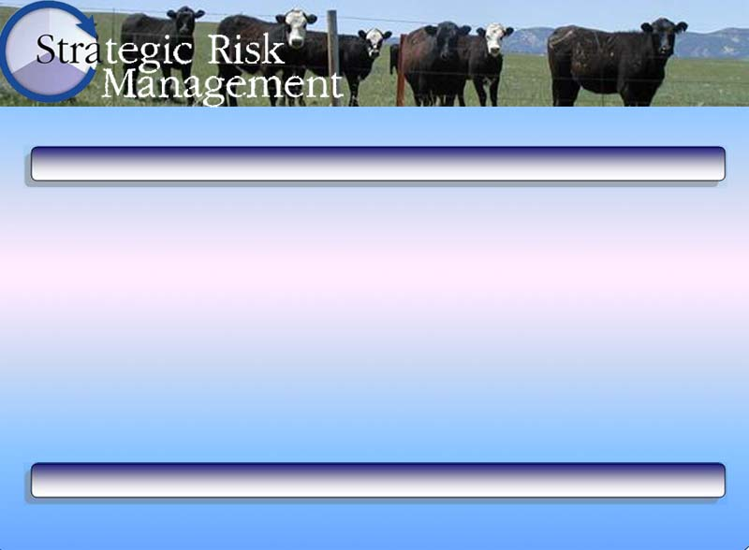
Transition Planning Worksheet

 |  |  | Beginning Benchmarks | Date: | Date: | Ending Benchmarks
 | Limiting Resource: |  |  | 1/1/07 | 1/1/07
Proposed Enterprise Changes | Enterprise: |  |  | 1/1/07 | 1/1/07
Proposed Enterprise Changes | Enterprise:  se |  |  | 1/1/07 | 1/1/07
Proposed Enterprise Changes | Enterprise: |  |  | 1/1/07 | 1/1/07
Resource Changes | Basic Resources (Natural and Agronomic):  Changes to Inputs: |  |  | 1/1/07 | 1/1/07
Resource Changes | Changes to Outputs: |  |  | 1/1/07 | 1/1/07
Resource Changes | Benchmarks: |  |  | 1/1/07 | 1/1/07
Resource Changes | Livestock/Wildlife Resources:  Changes to Inputs: |  |  | 1/1/07 | 1/1/07
Resource Changes | Changes to Outputs: |  |  | 1/1/07 | 1/1/07
Resource Changes | Benchmarks: |  |  | 1/1/07 | 1/1/07
Resource Changes | Human Resources:  Changes to Inputs |  |  | 1/1/07 | 1/1/07
Resource Changes | Changes to Outputs: |  |  | 1/1/07 | 1/1/07
Resource Changes | Benchmarks: |  |  | 1/1/07 | 1/1/07
Resource Changes | Financial Resources:  Changes to Inputs: |  |  | 1/1/07 | 1/1/07
Resource Changes | Changes to Outputs: |  |  | 1/1/07 | 1/1/07
Resource Changes | Benchmarks: |  |  | 1/1/07 | 1/1/07
SWOT Analysis |  | Strengths  Weaknesses  Opportunities  Threats |  | 1/1/07 | 1/1/07

