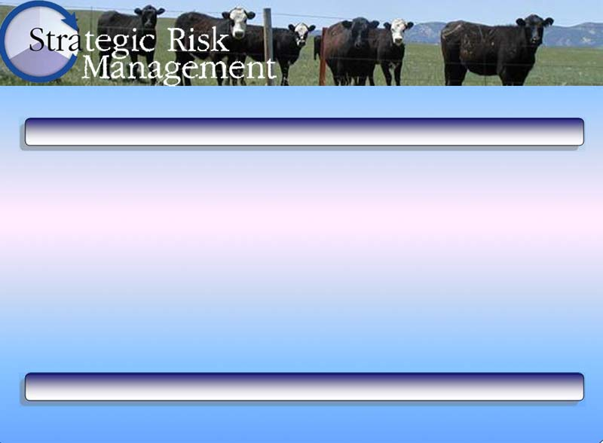
Time Management Matrix

The following table illustrates an example of how to use the Time Management Matrix:
 | Urgent | Not Urgent
Important | Quadrant I  Crises  Pressing Problems  Deadline-driven projects | Quadrant II  Prevention, Relationship building  Recognizing new opportunities,  Planning, Recreation
Not Important | Quadrant III  Interruptions, Some calls, Some mail,  Some reports, Some meetings, Pressing matters,  Popular activities | Quadrant IV  Trivia, Busy work, Some mail,  Some phone calls, Time wasters,  Pleasant activities, No-brainers
Adapted from The Seven Habits of Highly Effective People by Stephen R. Covey (1989).
Use this worksheet to categorize activities on which you spend a majority of your time.

 | Urgent | Not Urgent
Important | Quadrant I | Quadrant II
Not Important | Quadrant III | Quadrant IV
Adapted from The Seven Habits of Highly Effective People by Stephen R. Covey (1989).

