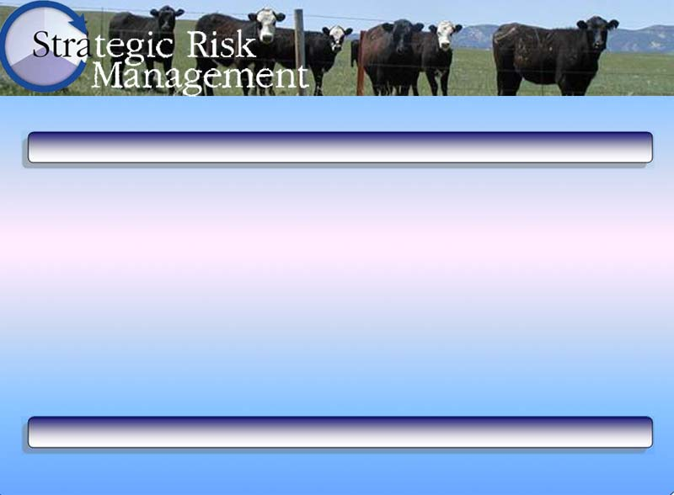
Strategic Goal Worksheet

Strategic Goal Worksheet
Goal Statement:

The goal statement is the written description of the goal to be accomplished.

Deadline for Goal Attainment:
Strategic goals should have and associated deadline. This helps prioritize your goals.
---------- Goal Costs/Resources Required: ----------
Basic Resources  Resources needed to achieve this strategic goal should be briefly described/listed in this section.  This will help in tactical planning for goal attainment. | Human Resources | Financial Resources | Livestock Resources | Wildlife Resources
Associated Tactical Objectives:

Tactical objectives and operational plans are the means used to accomplish strategic goals.

Briefly outline in this section the tactical steps necessary for reaching the strategic goal listed above. The operational steps are to be described below.

Associated Operational Plans:

Example Ranch

Strategic Goal Worksheet
Goal Statement:

Market recreational experiences by utilizing the ranch resources and ambiance.

Deadline for Goal Attainment: Fall of 20x7
---------- Goal Costs/Resources Required: ----------
Basic Resources  + Cattle-free, trash-free riparian areas  +Pristine big game hunting areas and camp sites | Human Resources  + Dad – 80 hrs  + Mom – 60 hrs  + Hired person #1 – 40 hrs | Financial Resources  + $9,000 to advertise birding and accommodations  + $3,000 to advertise trophy antelope and deer hunts  + $20,000 to develop remote camp sites | Livestock Resources  + Cow herd as backdrop for recreational activities  + Horses for packing big game trophies | Wildlife Resources  + Large, healthy trout  + Diverse and easily-viewed bird species  + Plentiful, healthy trophy antelope and deer
Associated Tactical Objectives:

Tactical Objectives 1-1: To market the blue-ribbon trout fishing opportunities of the ranch, available within 5 miles of the main highway through advertisements in select fishing magazines, grossing at least $20,000/year over the next 15 years.

Tactical Objectives 1-2: To market the bird-viewing opportunities of ranch riparian areas and high-quality, overnight accommodations to members of exclusive birding clubs from the greater Chicago area, providing gross returns of at least $50,000/year over the next 10 years.

Tactical Objectives 1-3: To exploit the big-game hunting opportunities of the more remote portions of the ranch beginning next hunting season, returning net earnings of $20,000/year over the next 10 years.

Associated Operational Plans: (for Tactical Objective 1-3 only)

Operational Plan 1-3.1: Consult with state Game and Fish personnel to set a target harvest level for the ranch that will give a 90 percent success rate at a cost of $1,500 per hunter. Person responsible: Dad. Complete by: February 15th.

Operational Plan 1-3.2: The EXAMPLE ranch currently has 390 antelope, 120 mule deer, and about 30 whitetail deer. With $3,000, advertise hunting ventures throughout the state. Person responsible: Mom. Complete by: March 31st.

Operational Plan 1-3.3: Develop six campsites on ranch with camp tables, BBQ pits, and outdoor toilets. Person responsible: Dad and hired person #1. Complete by: end of August.

Strategic Goal Worksheet
Goal Statement:

Deadline for Goal Attainment:
---------- Goal Costs/Resources Required: ----------
Basic Resources | Human Resources | Financial Resources | Livestock Resources | Wildlife Resources
Associated Tactical Objectives:

Associated Operational Plans:

