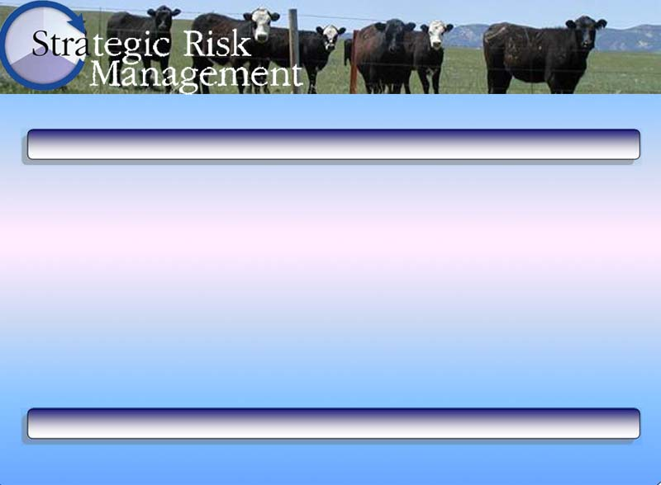
Mission Statement Worksheet

Mission Statement Worksheet
Describe your vision of the operation twenty years from now.  How do you see your business in the future? | List the things you want the operation to be or become:
What will the operation provide for you?  What would you like the operation to accomplish over the next twenty years? | List the things you want to do with the operation or things you want the operation to do for you or your family:
What does the operation produce or sell as products?  Are there products or means of marketing your resources that you see the operation being involved with over the next twenty years? | Describe the focus of the operation, what it is all about:

