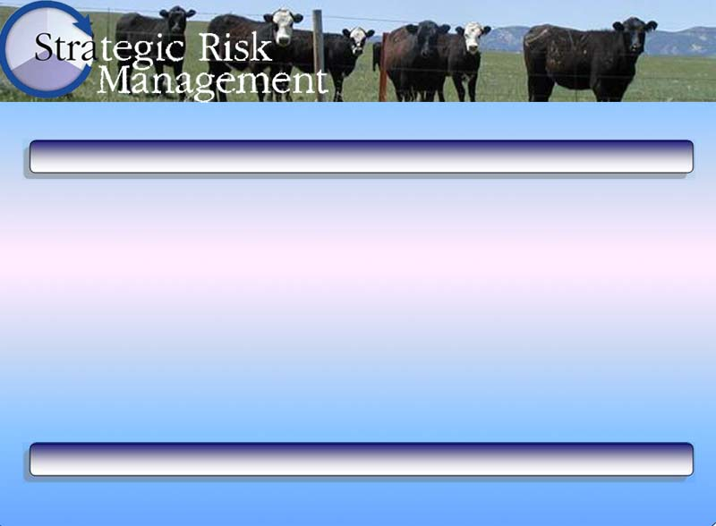
Management Team Roster

Management Team Roster
Is the coach Dad, Mom, Granddad, or someone else? | Who’s the coach?
Is the quarterback Dad, Mom, the ranch manager, an uncle or someone else? | Who’s the quarterback?
Are the player’s children, other family members, hired managers or workers, parents, stockholders, or others?  Do all who are actively involved in the operation really want to be?  Have you ever asked them if they want to be involved? | Who are the team players?
Are there children other family members, hired managers/workers, parents, stockholders, or others who would like to be actively involved in the operation?  Have you ever asked them if they want to be involved? | Are there any players on the bench who would like to be in the game?

